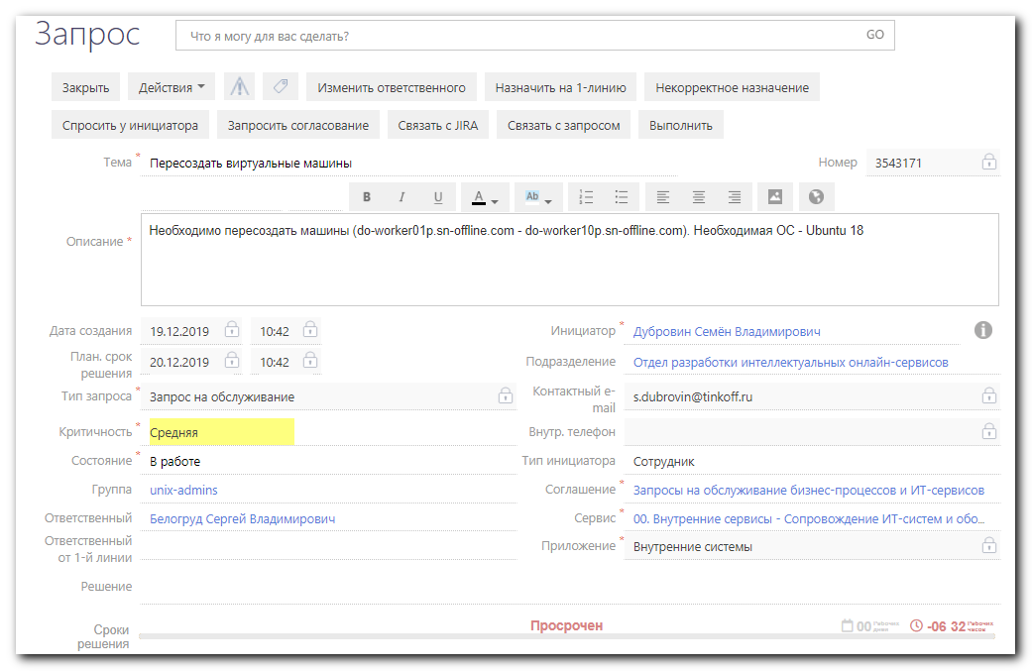

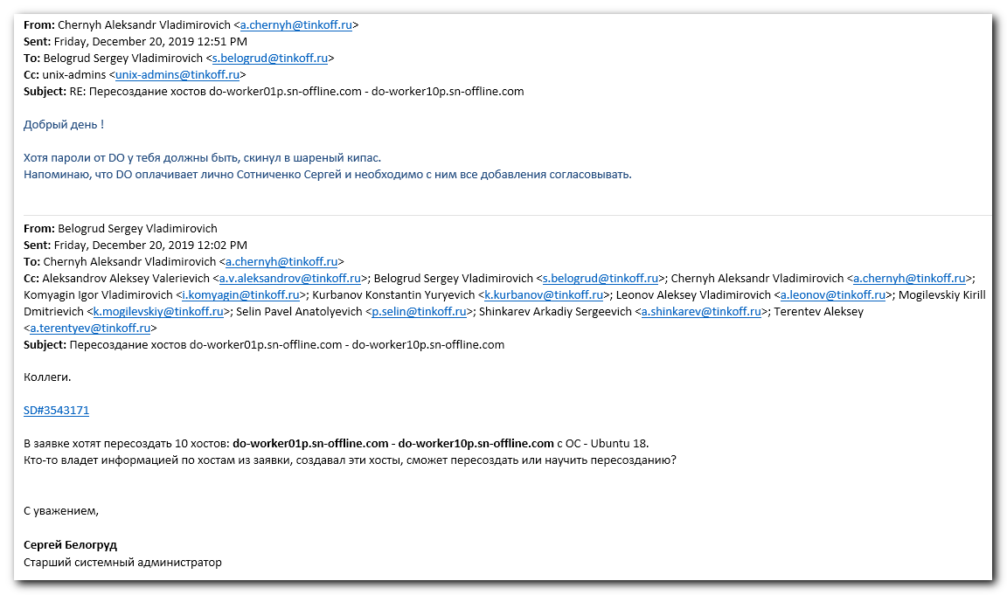
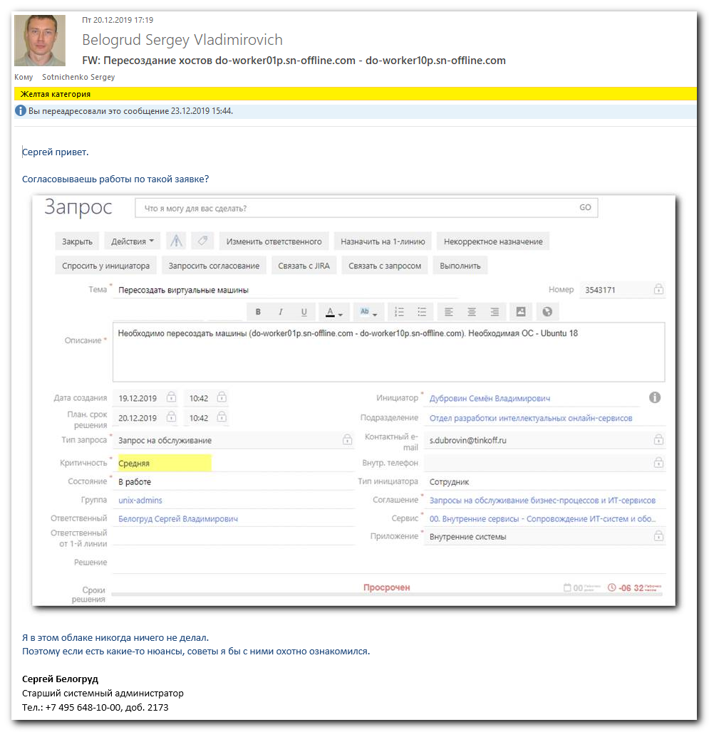

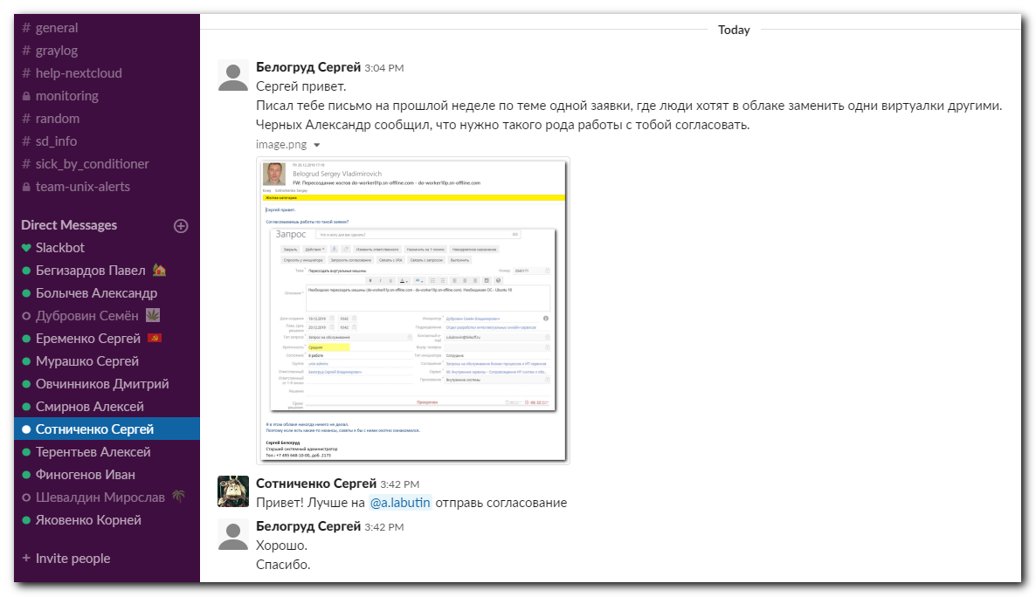

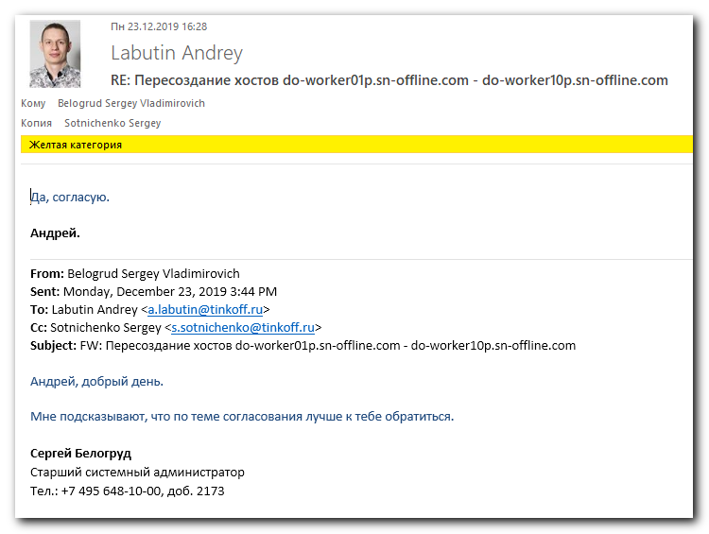

#
# 20191223
# Login process to Digital Ocean cloud.
#
https://cloud.digitalocean.com/

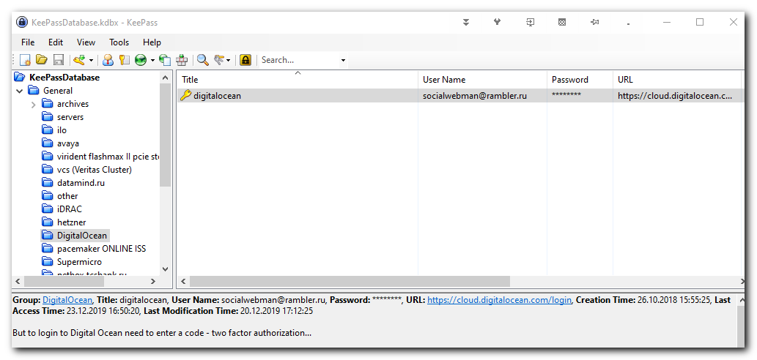

https://mail.rambler.ru/#/folder/INBOX
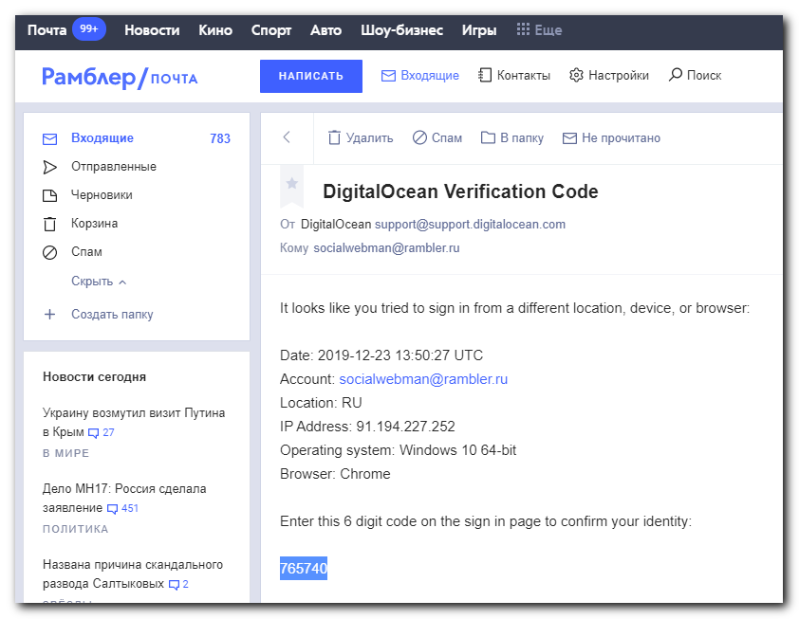
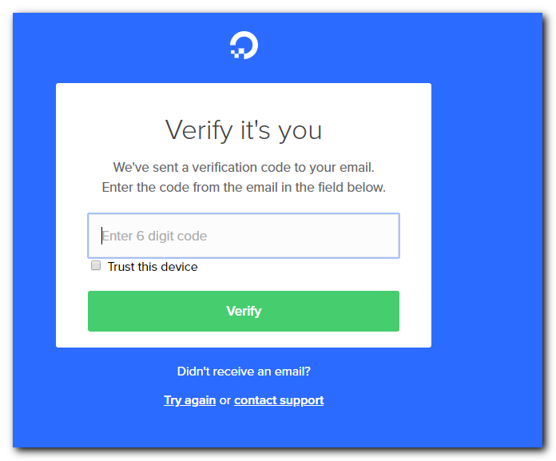


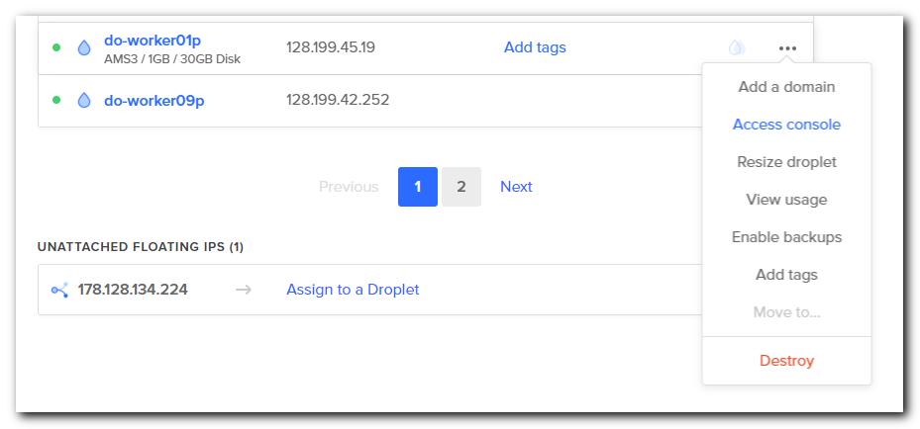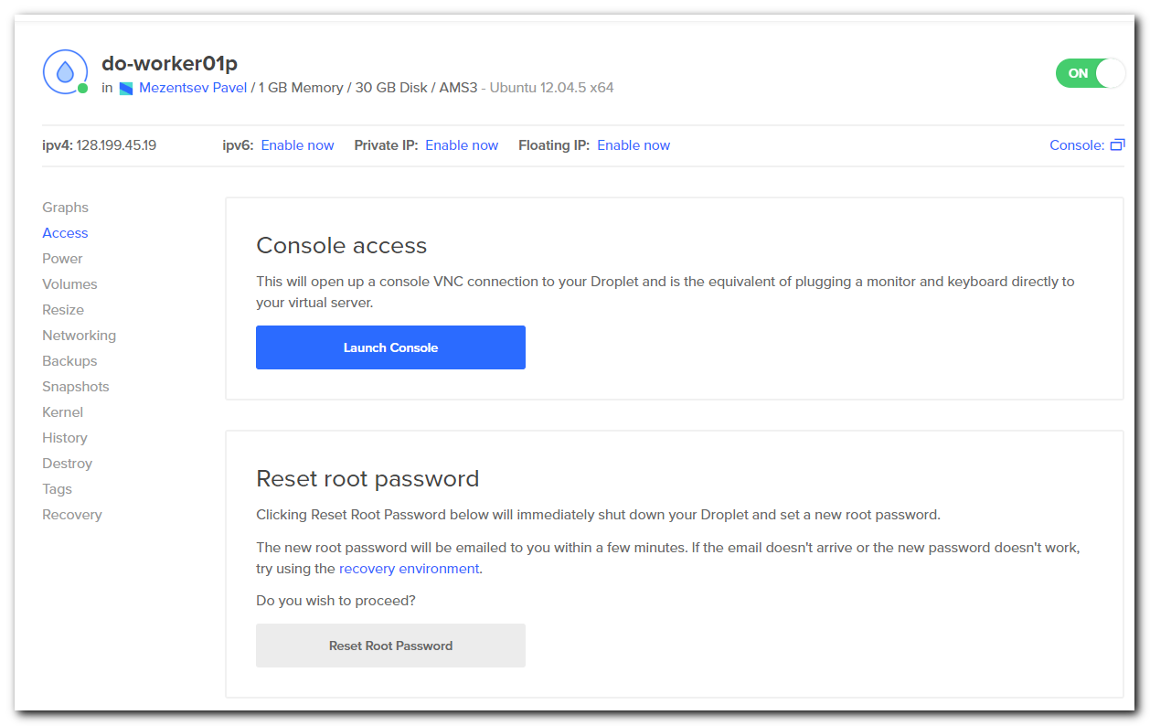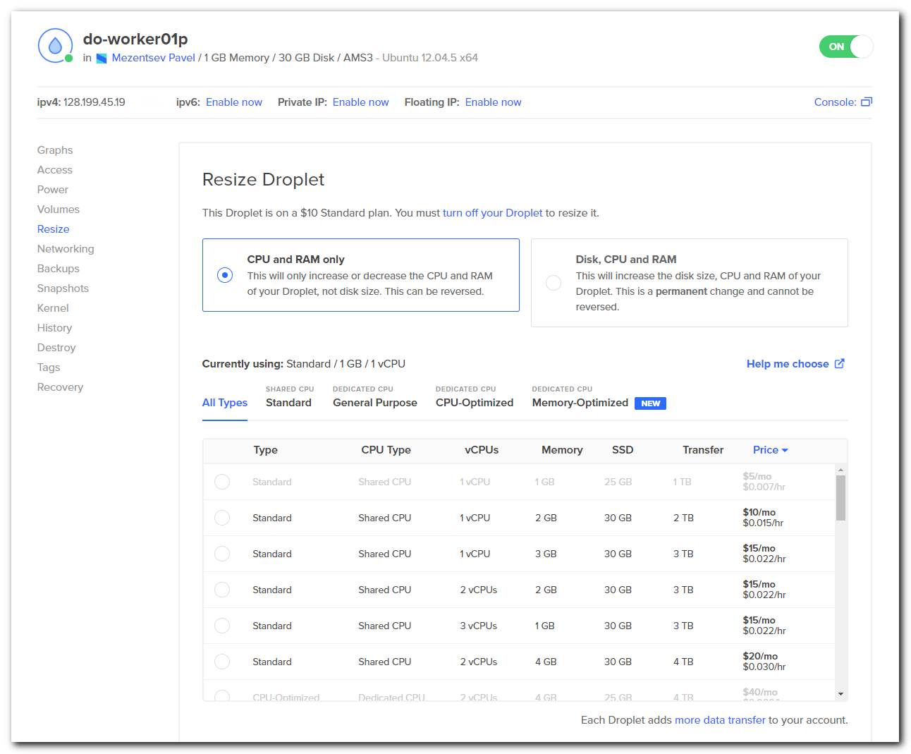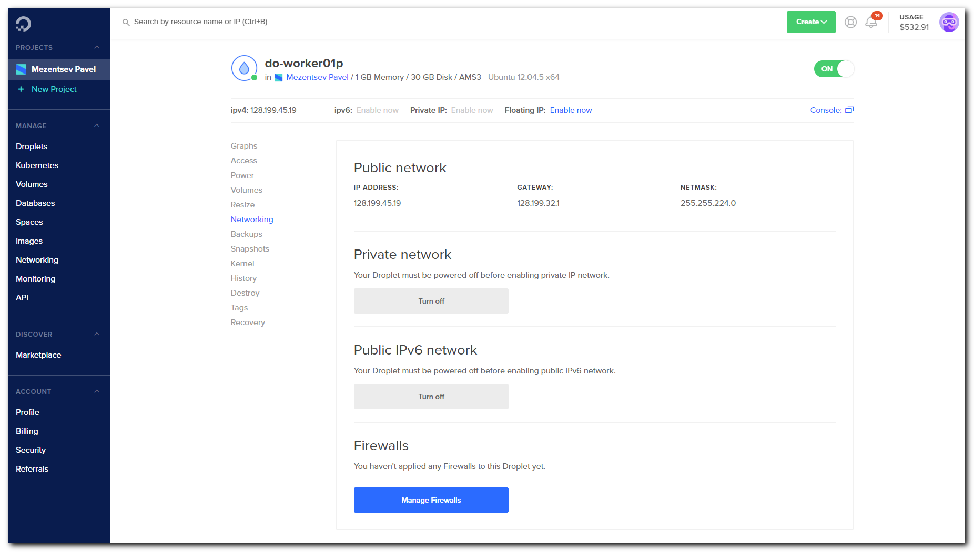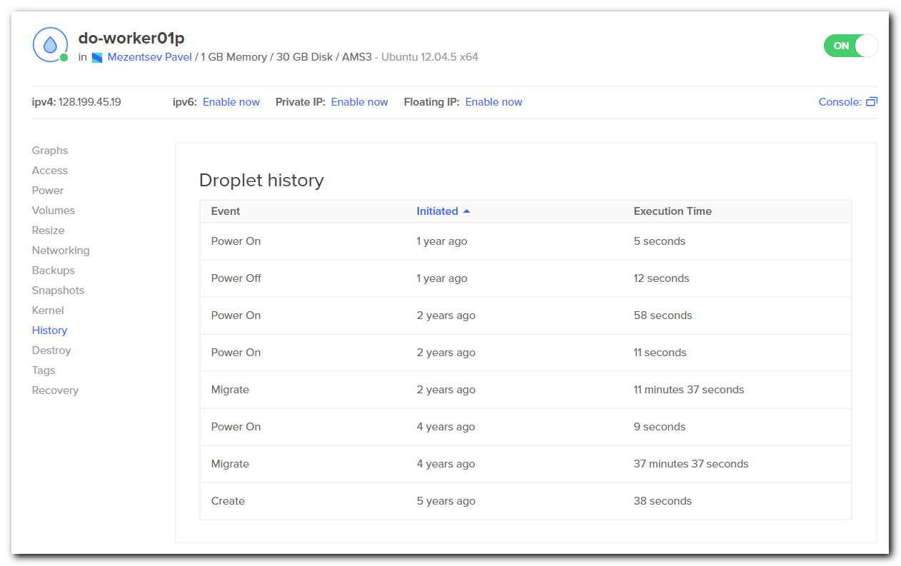

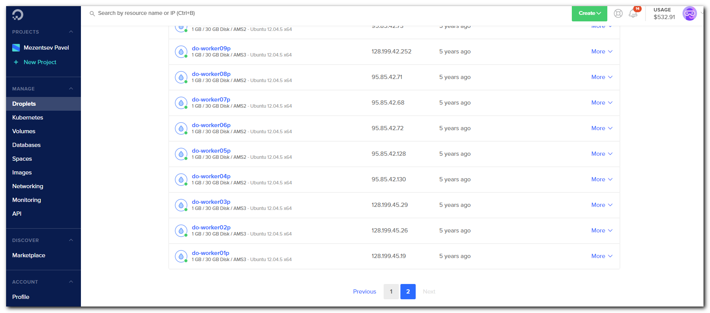

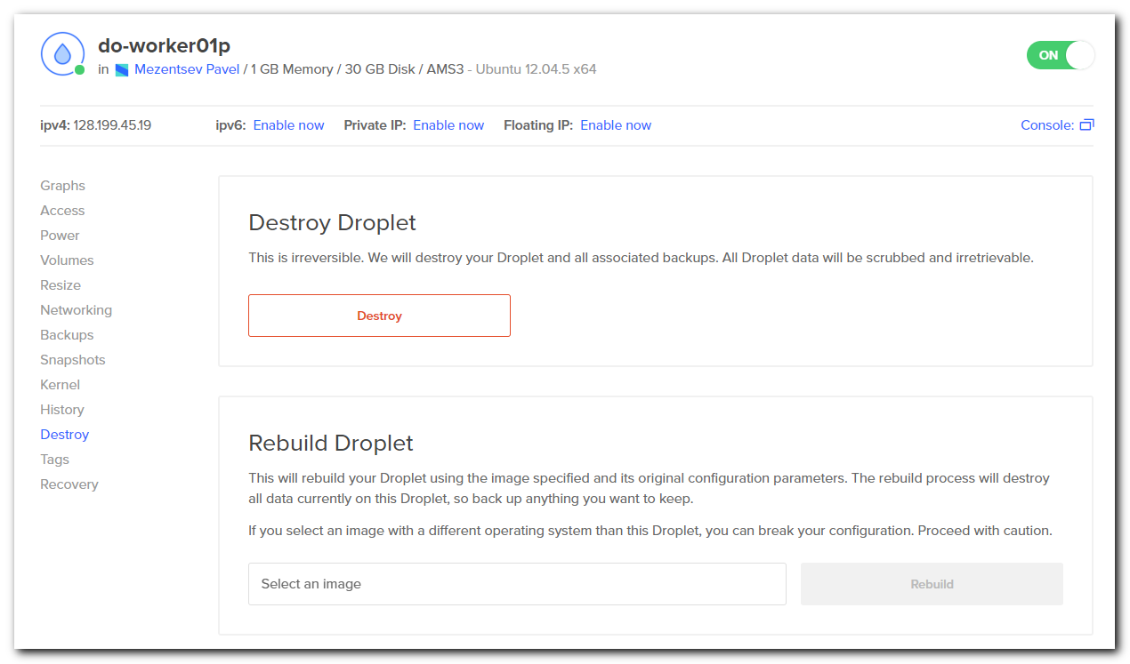
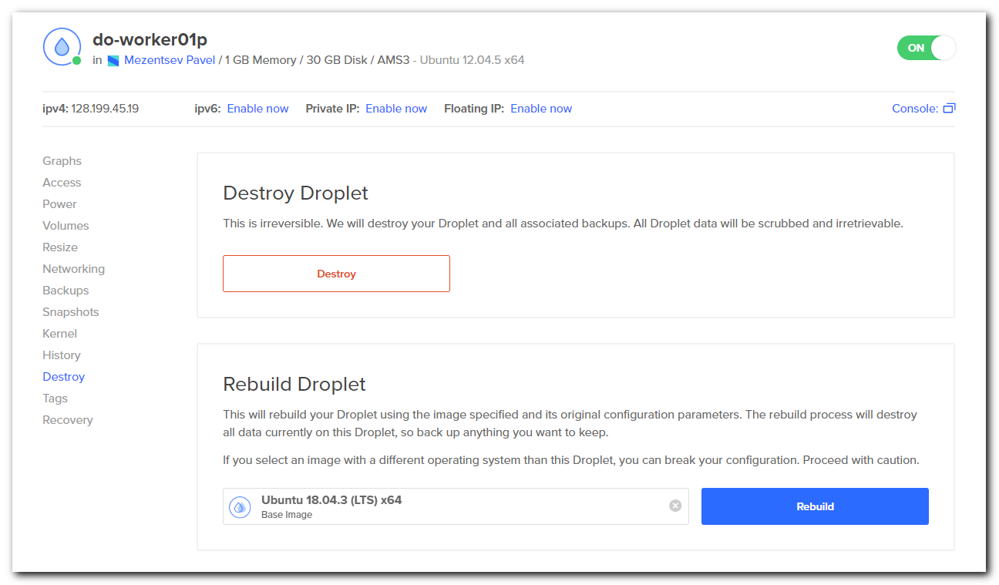

#
# I’ve enabled backup for this host. But it will be made only on weekends and not immedietely.
# So - it useless for in my case.
#
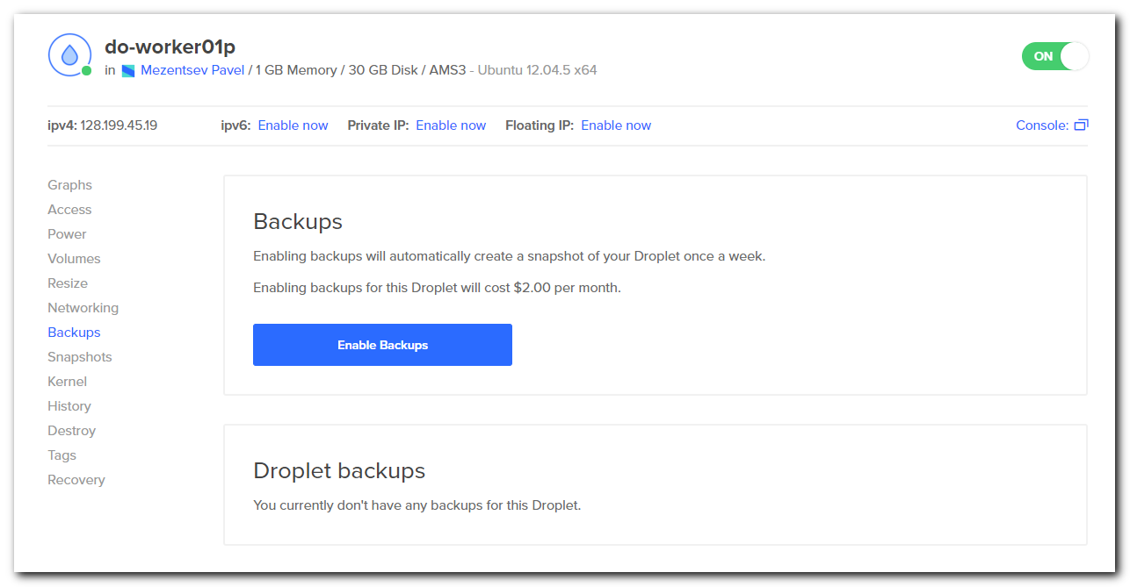
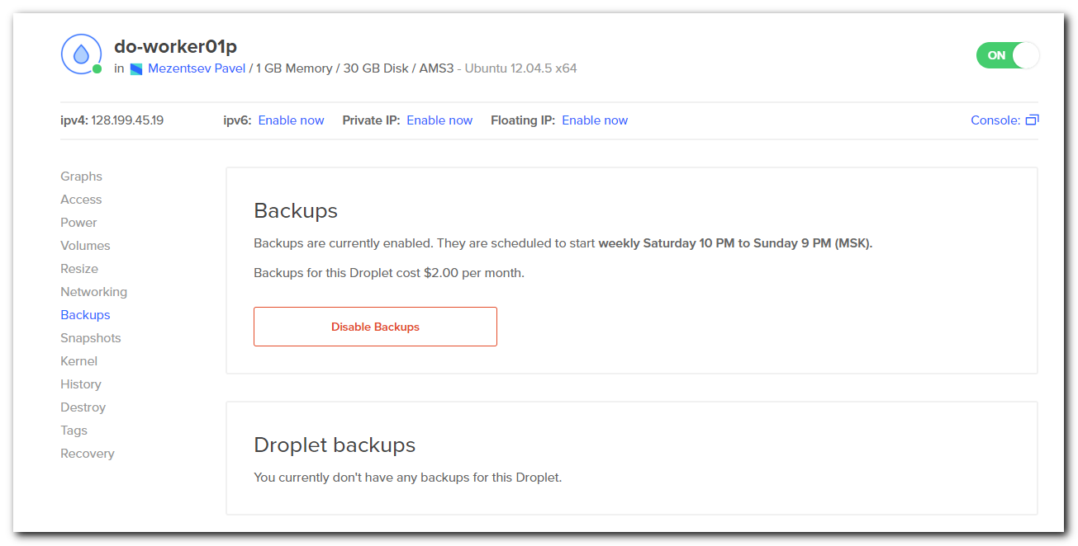

#
# I’ve disable it back again.
#
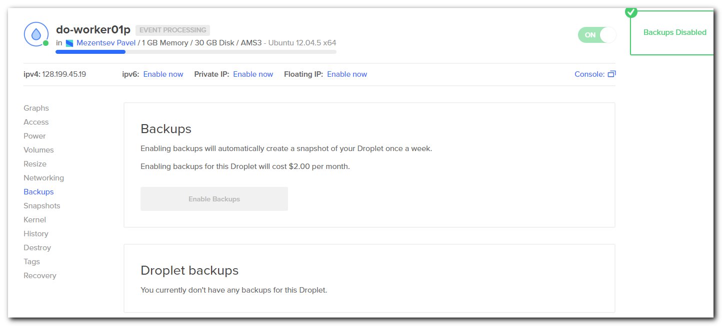

#
# Now buttons are unavailable. I think it’s after my attempt to make backup for this host.
#
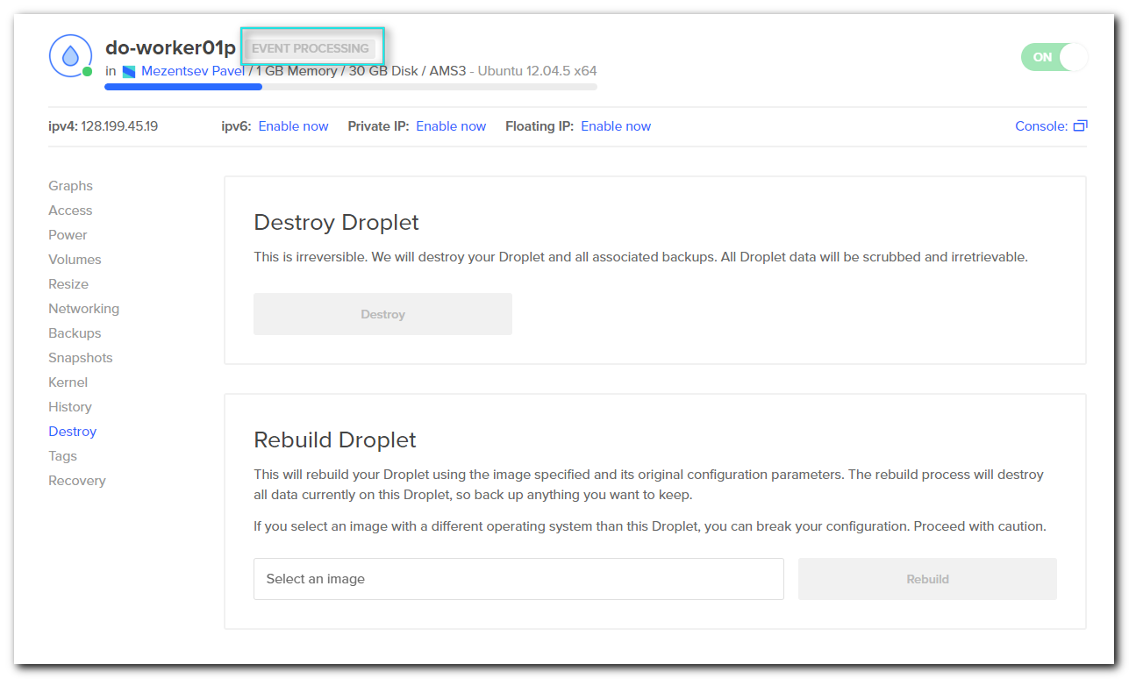
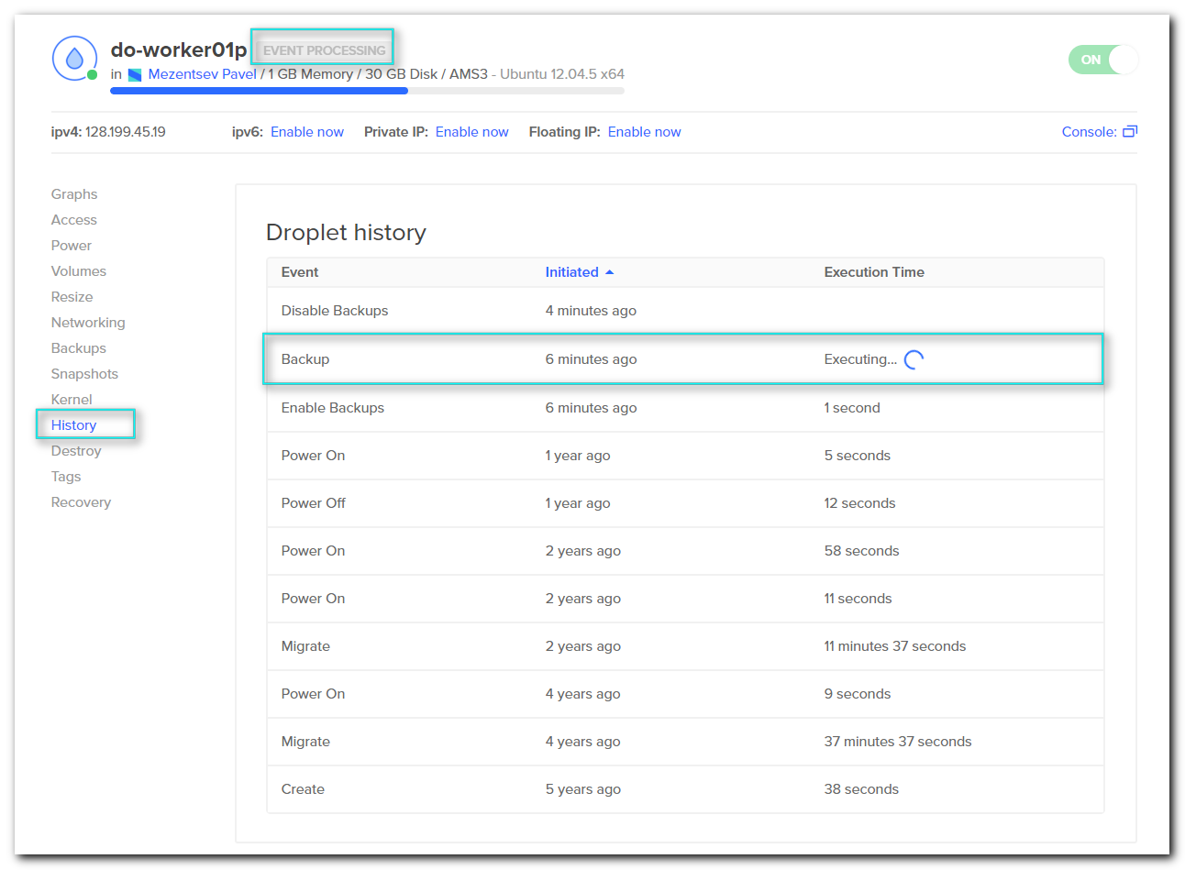

#
# I will try to rebuild next available host.
#
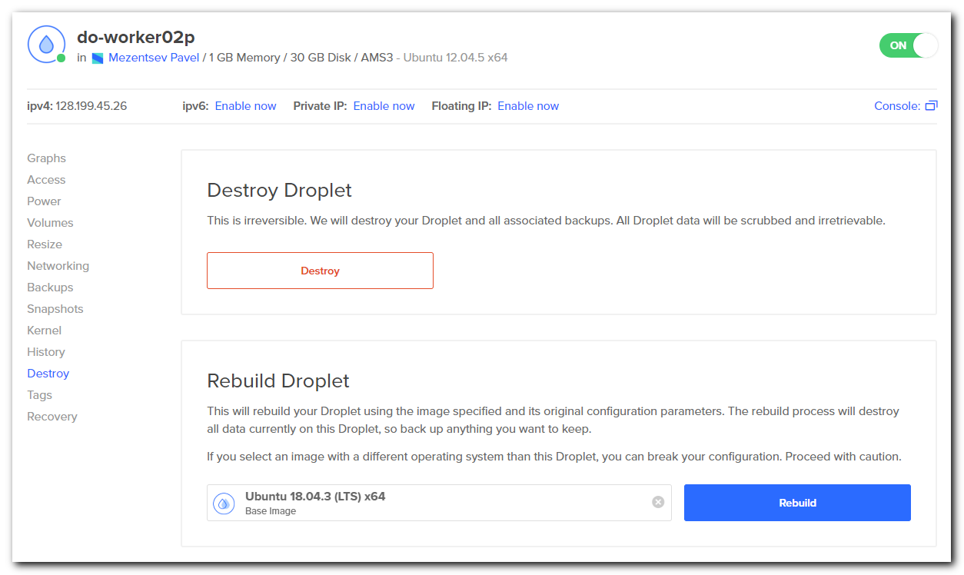
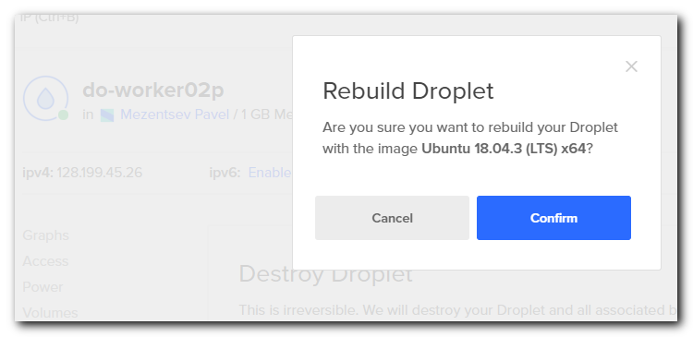
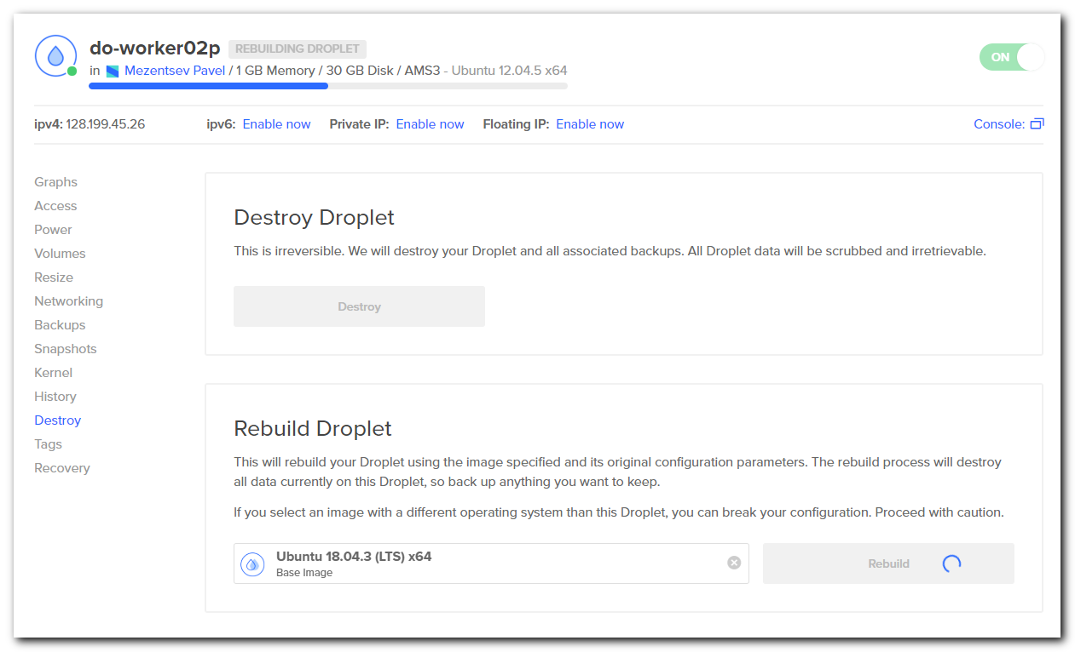

#
# Less, than minute - and this droplet (virtual host) was rebuilt.
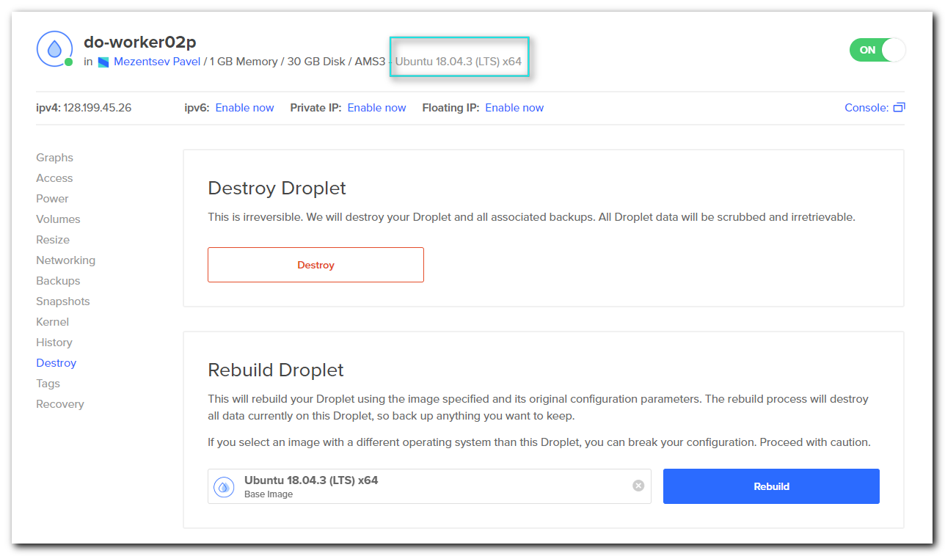

#
# It looks like access to ssh to fresh created host - exists.
#
[s.belogrud@TCS4357]# ssh bsv@do-worker02p.sn-offline.com
Warning: Permanently added 'do-worker02p.sn-offline.com' (RSA) to the list of known hosts.
Permission denied (publickey).
[s.belogrud@TCS4357]#

#
# As I see, for other hosts - I have access. It’s need not require key. I have access via password.
#
[s.belogrud@TCS4357]# ssh bsv@do-worker01p.sn-offline.com
Warning: Permanently added 'do-worker01p.sn-offline.com' (RSA) to the list of known hosts.
bsv@do-worker01p.sn-offline.com's password:

[s.belogrud@TCS4357]#

[s.belogrud@TCS4357]# ssh bsv@do-worker01p.sn-offline.com
bsv@do-worker01p.sn-offline.com's password:
Welcome to Ubuntu 14.04.6 LTS (GNU/Linux 3.13.0-32-generic x86_64)

* Documentation: https://help.ubuntu.com/

System information as of Mon Dec 23 17:10:02 MSK 2019

System load: 0.0 Processes: 107
Usage of /: 49.4% of 29.40GB Users logged in: 0
Memory usage: 25% IP address for eth0: 128.199.45.19
Swap usage: 0%

Graph this data and manage this system at:
https://landscape.canonical.com/

New release '16.04.6 LTS' available.
Run 'do-release-upgrade' to upgrade to it.

Your current Hardware Enablement Stack (HWE) is no longer supported
since 2014-08-07. Security updates for critical parts (kernel
and graphics stack) of your system are no longer available.

For more information, please see:
http://wiki.ubuntu.com/1204_HWE_EOL

To upgrade to a supported (or longer supported) configuration:

* Upgrade from Ubuntu 12.04 LTS to Ubuntu 14.04 LTS by running:
sudo do-release-upgrade

OR

* Install a newer HWE version by running:
sudo apt-get install linux-generic-lts-trusty linux-image-generic-lts-trusty

and reboot your system.

*** System restart required ***

The programs included with the Ubuntu system are free software;
the exact distribution terms for each program are described in the
individual files in /usr/share/doc/*/copyright.

Ubuntu comes with ABSOLUTELY NO WARRANTY, to the extent permitted by
applicable law.

bsv@do-worker01p:~$ sudo -i
[sudo] password for bsv:
root@do-worker01p:~#

#
# Now I try to reset root password to get access to console. To test - how it is at all.
#
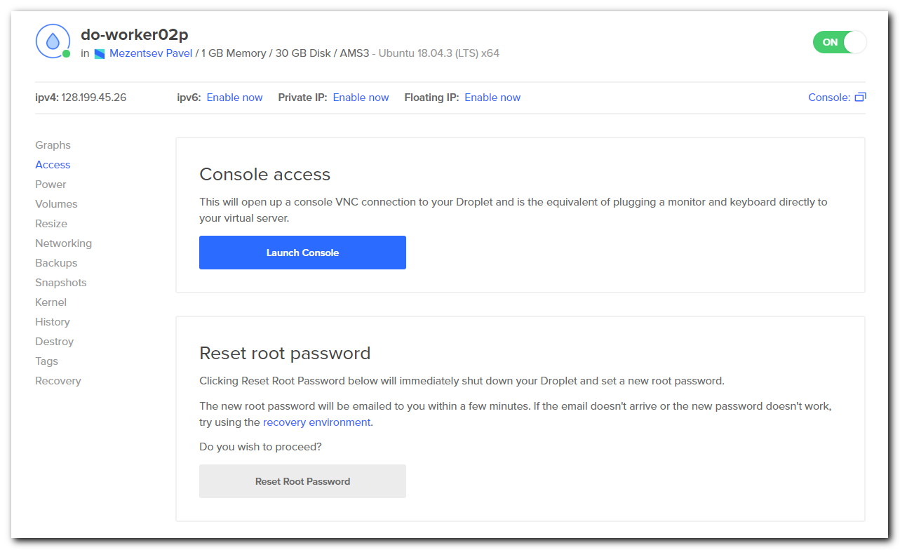
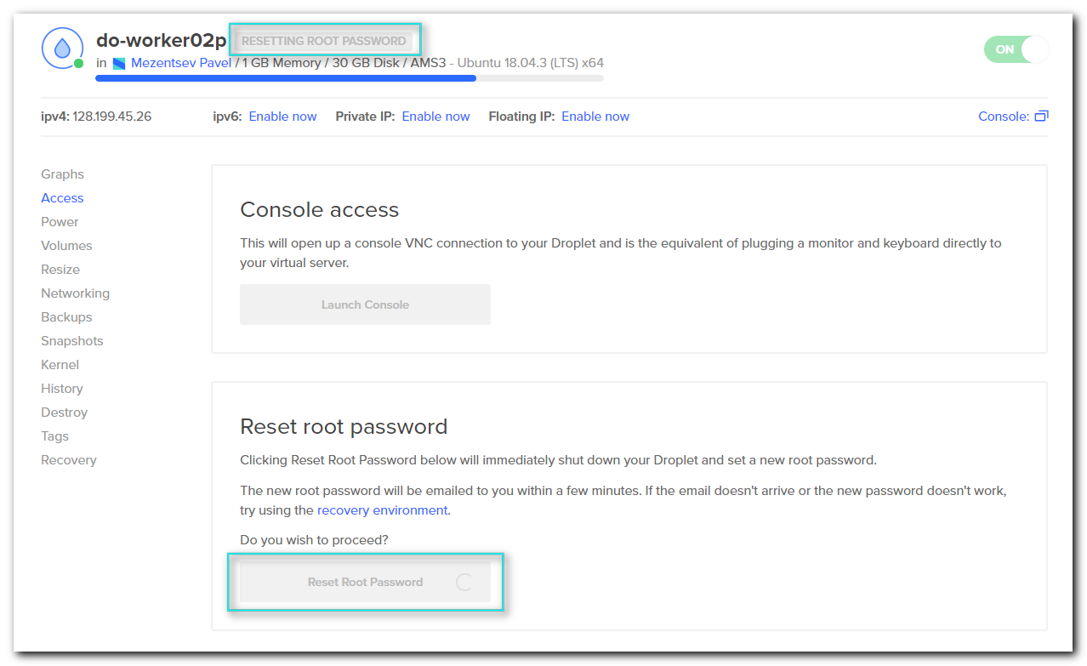

#
# Here is the password to console.
#
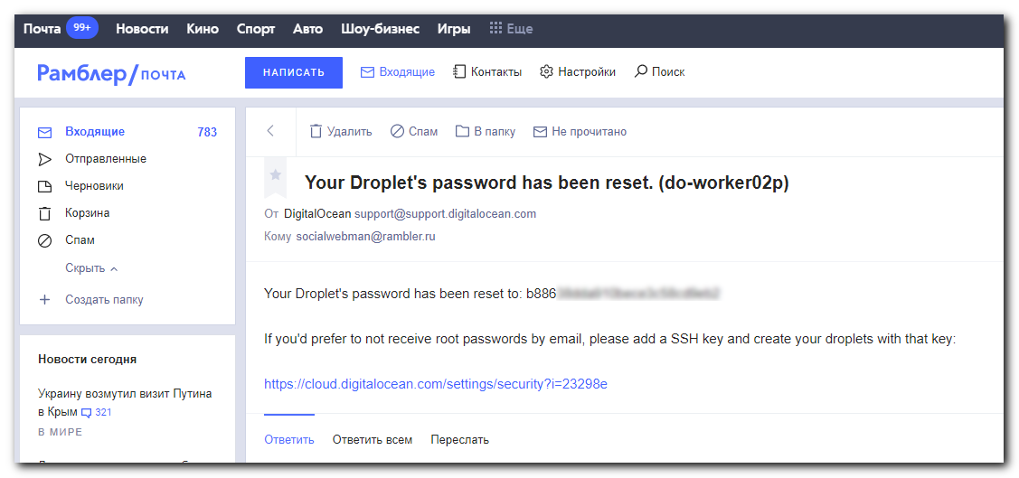

#
# It’s need to use Ctrl+v to paste new generated password
#
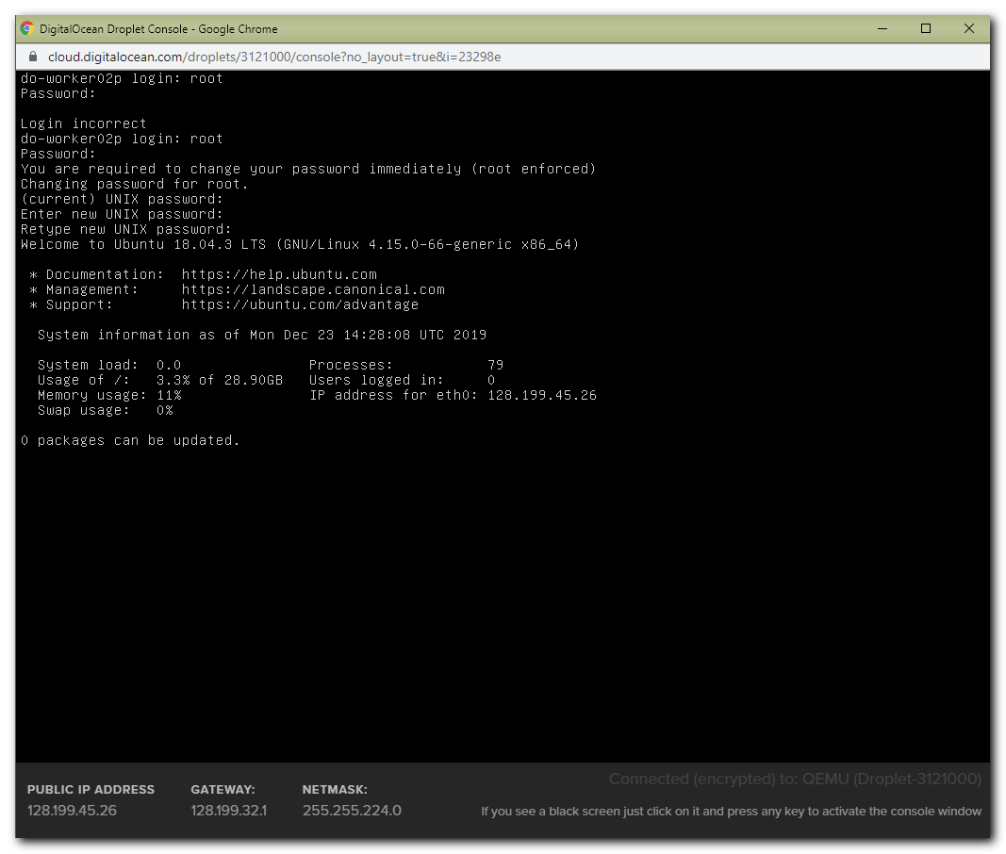

#
# Follow steps I’ve done with console.
#

#
# It's need to comment line, that allow only key authorization.
#
bsv@do-worker02p:~$ grep -e "PasswordAuthentication " /etc/ssh/sshd_config
#PasswordAuthentication yes
bsv@do-worker02p:~$

root@do-worker02p:~$ systemctl restart sshd

groupadd -g 525 bsv && useradd -u 525 -g bsv -G sudo -m -s /bin/bash -p '$6$vA7VSeUYxsvNmTXp$m5ogKX3o8zsQd7dG/38nTLSsE32cKFB6Eqv2vdlLy5mZ0U4Ky6qu7o0Z/vR92wIdVlzoTsb2QpYlfz6zlEvcs.' bsv

#
# Here is a wrong key. Need not to copy it.
#
bsv@do-worker01p:~$ scp .ssh/authorized_keys bsv@do-worker02p.sn-offline.com:~bsv/.ssh/
bsv@do-worker02p.sn-offline.com's password:
authorized_keys 100% 771 0.8KB/s 00:00
bsv@do-worker01p:~$

#
# This playbook was used to crate all other accounts on new server.
#
[support@centos digitalocean]$ ansible-playbook create.users.in.digitalocean.yml -i list_of_hosts --become --extra-vars "ansible_user=bsv ansible_password=$(pass common/linux-other4) ansible_sudo_pass=$(pass common/linux-other4) ansible_ssh_common_args='-oStrictHostKeyChecking=no -oPubkeyAuthentication=no'"

root@do-worker01p:~# scp /etc/ssh/sshd_config root@do-worker02p.sn-offline.com:/etc/ssh/
Warning: the ECDSA host key for 'do-worker02p.sn-offline.com' differs from the key for the IP address '128.199.45.26'
Offending key for IP in /root/.ssh/known_hosts:3
Matching host key in /root/.ssh/known_hosts:6
Are you sure you want to continue connecting (yes/no)? yes
root@do-worker02p.sn-offline.com's password:
sshd_config 100% 2503 2.4KB/s 00:00
root@do-worker01p:~#

[root@vm-vol-nag4-tst objects]# pwgen -c -n -s -y -B -C 16 1
******
[root@vm-vol-nag4-tst objects]#

root@do-worker02p:~# passwd
Enter new UNIX password:
Retype new UNIX password:
passwd: password updated successfully
root@do-worker02p:~#

#
# Tested step of workflow.
#

- Remake host.
- Reset password for the new host.
- Login on host via console and allow ssh connection with password. Restart sshd.
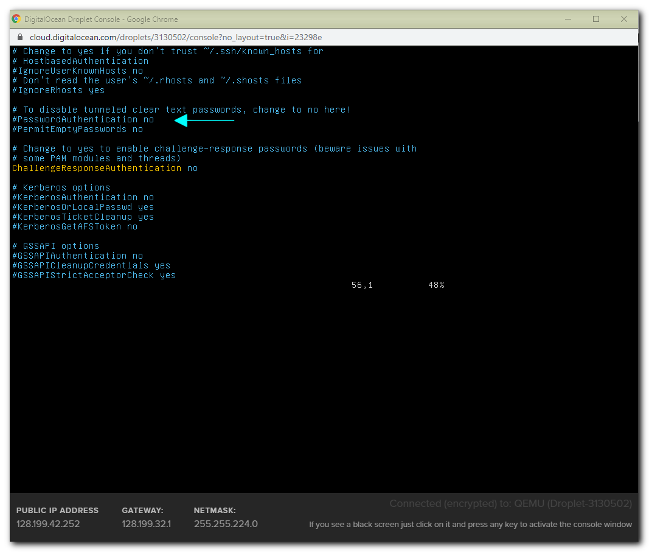
- Execute playbook to create users.

[support@centos digitalocean]$ ansible-playbook create.users.in.digitalocean.yml -i list_of_hosts --become --extra-vars "ansible_user=root ansible_password=$(pass common/linux-other4) ansible_sudo_pass=$(pass common/linux-other4) ansible_ssh_common_args='-oStrictHostKeyChecking=no -oPubkeyAuthentication=no'"

#
# 5. Copy sshd_config. Restart sshd on target server.
#
root@do-worker01p:~# scp /etc/ssh/sshd_config root@do-worker03p.sn-offline.com:/etc/ssh/
The authenticity of host 'do-worker03p.sn-offline.com (128.199.45.29)' can't be established.
ECDSA key fingerprint is 22:10:86:e4:54:05:a0:af:48:ae:77:ac:ac:f3:f2:03.
Are you sure you want to continue connecting (yes/no)? yes
Warning: Permanently added 'do-worker03p.sn-offline.com,128.199.45.29' (ECDSA) to the list of known hosts.
root@do-worker03p.sn-offline.com's password:
sshd_config 100% 2503 2.4KB/s 00:00
root@do-worker01p:~#

#
# 6. Change root password to hard and random generated.
#
root@do-worker03p:~# passwd
Enter new UNIX password:
Retype new UNIX password:
passwd: password updated successfully
root@do-worker03p:~#

#
# If require root login via password - it’s need to do follow changes in /etc/ssh/sshd_config
#
#PermitRootLogin without-password
PermitRootLogin yes

................................................................................

#
# Here is sshd config, that had made, when this host was created.
#
root@do-worker01p:~# cat /etc/ssh/sshd_config
# Package generated configuration file
# See the sshd_config(5) manpage for details

# What ports, IPs and protocols we listen for
Port 22
# Use these options to restrict which interfaces/protocols sshd will bind to
#ListenAddress ::
#ListenAddress 0.0.0.0
Protocol 2
# HostKeys for protocol version 2
HostKey /etc/ssh/ssh_host_rsa_key
HostKey /etc/ssh/ssh_host_dsa_key
HostKey /etc/ssh/ssh_host_ecdsa_key
#Privilege Separation is turned on for security
UsePrivilegeSeparation yes

# Lifetime and size of ephemeral version 1 server key
KeyRegenerationInterval 3600
ServerKeyBits 1024

# Logging
SyslogFacility AUTH
LogLevel INFO

# Authentication:
LoginGraceTime 120
PermitRootLogin without-password
StrictModes yes

RSAAuthentication yes
PubkeyAuthentication yes
#AuthorizedKeysFile %h/.ssh/authorized_keys

# Don't read the user's ~/.rhosts and ~/.shosts files
IgnoreRhosts yes
# For this to work you will also need host keys in /etc/ssh_known_hosts
RhostsRSAAuthentication no
# similar for protocol version 2
HostbasedAuthentication no
# Uncomment if you don't trust ~/.ssh/known_hosts for RhostsRSAAuthentication
#IgnoreUserKnownHosts yes

# To enable empty passwords, change to yes (NOT RECOMMENDED)
PermitEmptyPasswords no

# Change to yes to enable challenge-response passwords (beware issues with
# some PAM modules and threads)
ChallengeResponseAuthentication no

# Change to no to disable tunnelled clear text passwords
#PasswordAuthentication yes

# Kerberos options
#KerberosAuthentication no
#KerberosGetAFSToken no
#KerberosOrLocalPasswd yes
#KerberosTicketCleanup yes

# GSSAPI options
#GSSAPIAuthentication no
#GSSAPICleanupCredentials yes

X11Forwarding yes
X11DisplayOffset 10
PrintMotd no
PrintLastLog yes
TCPKeepAlive yes
#UseLogin no

#MaxStartups 10:30:60
#Banner /etc/issue.net

# Allow client to pass locale environment variables
AcceptEnv LANG LC_*

Subsystem sftp /usr/lib/openssh/sftp-server

# Set this to 'yes' to enable PAM authentication, account processing,
# and session processing. If this is enabled, PAM authentication will
# be allowed through the ChallengeResponseAuthentication and
# PasswordAuthentication. Depending on your PAM configuration,
# PAM authentication via ChallengeResponseAuthentication may bypass
# the setting of "PermitRootLogin without-password".
# If you just want the PAM account and session checks to run without
# PAM authentication, then enable this but set PasswordAuthentication
# and ChallengeResponseAuthentication to 'no'.
UsePAM yes
root@do-worker01p:~#

................................................................................

#
# Here is backup default sshd config.
#

root@do-worker02p:~# cat work/20191224-1218/sshd_config
# $OpenBSD: sshd_config,v 1.101 2017/03/14 07:19:07 djm Exp $

# This is the sshd server system-wide configuration file. See
# sshd_config(5) for more information.

# This sshd was compiled with PATH=/usr/bin:/bin:/usr/sbin:/sbin

# The strategy used for options in the default sshd_config shipped with
# OpenSSH is to specify options with their default value where
# possible, but leave them commented. Uncommented options override the
# default value.

#Port 22
#AddressFamily any
#ListenAddress 0.0.0.0
#ListenAddress ::

#HostKey /etc/ssh/ssh_host_rsa_key
#HostKey /etc/ssh/ssh_host_ecdsa_key
#HostKey /etc/ssh/ssh_host_ed25519_key

# Ciphers and keying
#RekeyLimit default none

# Logging
#SyslogFacility AUTH
#LogLevel INFO

# Authentication:

#LoginGraceTime 2m
PermitRootLogin yes
#StrictModes yes
#MaxAuthTries 6
#MaxSessions 10

#PubkeyAuthentication yes

# Expect .ssh/authorized_keys2 to be disregarded by default in future.
#AuthorizedKeysFile .ssh/authorized_keys .ssh/authorized_keys2

#AuthorizedPrincipalsFile none

#AuthorizedKeysCommand none
#AuthorizedKeysCommandUser nobody

# For this to work you will also need host keys in /etc/ssh/ssh_known_hosts
#HostbasedAuthentication no
# Change to yes if you don't trust ~/.ssh/known_hosts for
# HostbasedAuthentication
#IgnoreUserKnownHosts no
# Don't read the user's ~/.rhosts and ~/.shosts files
#IgnoreRhosts yes

# To disable tunneled clear text passwords, change to no here!
#PasswordAuthentication no
#PermitEmptyPasswords no

# Change to yes to enable challenge-response passwords (beware issues with
# some PAM modules and threads)
ChallengeResponseAuthentication no

# Kerberos options
#KerberosAuthentication no
#KerberosOrLocalPasswd yes
#KerberosTicketCleanup yes
#KerberosGetAFSToken no

# GSSAPI options
#GSSAPIAuthentication no
#GSSAPICleanupCredentials yes
#GSSAPIStrictAcceptorCheck yes
#GSSAPIKeyExchange no

# Set this to 'yes' to enable PAM authentication, account processing,
# and session processing. If this is enabled, PAM authentication will
# be allowed through the ChallengeResponseAuthentication and
# PasswordAuthentication. Depending on your PAM configuration,
# PAM authentication via ChallengeResponseAuthentication may bypass
# the setting of "PermitRootLogin yes
# If you just want the PAM account and session checks to run without
# PAM authentication, then enable this but set PasswordAuthentication
# and ChallengeResponseAuthentication to 'no'.
UsePAM yes

#AllowAgentForwarding yes
#AllowTcpForwarding yes
#GatewayPorts no
X11Forwarding yes
#X11DisplayOffset 10
#X11UseLocalhost yes
#PermitTTY yes
PrintMotd no
#PrintLastLog yes
#TCPKeepAlive yes
#UseLogin no
#PermitUserEnvironment no
#Compression delayed
#ClientAliveInterval 0
#ClientAliveCountMax 3
#UseDNS no
#PidFile /var/run/sshd.pid
#MaxStartups 10:30:100
#PermitTunnel no
#ChrootDirectory none
#VersionAddendum none

# no default banner path
#Banner none

# Allow client to pass locale environment variables
AcceptEnv LANG LC_*

# override default of no subsystems
Subsystem sftp /usr/lib/openssh/sftp-server

# Example of overriding settings on a per-user basis
#Match User anoncvs
# X11Forwarding no
# AllowTcpForwarding no
# PermitTTY no
# ForceCommand cvs server
root@do-worker02p:~#

................................................................................

